INTRODUCTION

A To-Do List Application is a productivity tool that helps users organize and manage tasks efficiently. It allows users to create, update, prioritize, and track tasks, ensuring nothing is missed and deadlines are met. This application simplifies task management, making it ideal for personal, professional, or academic use.

Methodology used

Requirement Analysis:
Understanding the features and functionality the app should have (e.g., task creation, reminders).

Design:
Planning how the app will look (user interface) and how data (tasks) will be stored (database).

Development:
Writing the code for both the front-end (what the user interacts with) and back-end (how data is processed and stored).

Testing:
Checking if the app works as expected and fixing any issues (bugs).

Deployment:
Making the app available for use on devices like smartphones or on the web.

Feedback:
Gathering opinions from users to improve the app further.

Software requirements

Operating System:
- Windows
- Linux
- Android
- iOS

Languages:
- HTML,
- CSS
- JavaScript
- Python
- Java

Frameworks:
- React
- Angular

Database:
- SQLite
- MySQL

Tools:
Visual Studio Code, Android Studio, Git, and testing tools like Postman or Selenium.
Program code
import os

# File to store tasks
TASK_FILE = “tasks.txt”

def load_tasks():
“””Load tasks from a file.”””
tasks = []
if os.path.exists(TASK_FILE):
with open(TASK_FILE, “r”) as file:
tasks = [line.strip() for line in file.readlines()]
return tasks

def save_tasks(tasks):
“””Save tasks to a file.”””
with open(TASK_FILE, “w”) as file:
for task in tasks:
file.write(f”{task}\n”)

def add_task(tasks):
“””Add a new task to the list.”””
task = input(“Enter the task description: “)
tasks.append(task)
print(f”Task ‘{task}’ added.”)

def view_tasks(tasks):
“””Display all tasks with their statuses.”””
if not tasks:
print(“No tasks available.”)
else:
for index, task in enumerate(tasks, start=1):
print(f”{index}. {task}”)

def mark_task_complete(tasks):
“””Mark a task as completed.”””
view_tasks(tasks)
try:
task_number = int(input(“Enter the task number to mark as complete: “))
tasks[task_number – 1] = “[Completed] “ + tasks[task_number – 1]
print(f”Task {task_number} marked as complete.”)
except (ValueError, IndexError):
print(“Invalid task number.”)

def delete_task(tasks):
“””Delete a task from the list.”””
view_tasks(tasks)
try:
task_number = int(input(“Enter the task number to delete: “))
task = tasks.pop(task_number – 1)
print(f”Task ‘{task}’ deleted.”)
except (ValueError, IndexError):
print(“Invalid task number.”)

def main():
“””Main function to run the To-Do List app.”””
tasks = load_tasks()

while True:
print(“\nTo-Do List App”)
print(“1. View Tasks”)
print(“2. Add Task”)
print(“3. Mark Task as Completed”)
print(“4. Delete Task”)
print(“5. Exit”)

choice = input(“Choose an option (1-5): “)

if choice == “1”:
view_tasks(tasks)
elif choice == “2”:
add_task(tasks)
save_tasks(tasks)
elif choice == “3”:
mark_task_complete(tasks)
save_tasks(tasks)
elif choice == “4”:
delete_task(tasks)
save_tasks(tasks)
elif choice == “5”:
print(“Exiting the app. Goodbye!”)
break
else:
print(“Invalid choice. Please try again.”)

if __name__ == “__main__”:
main()

Program output

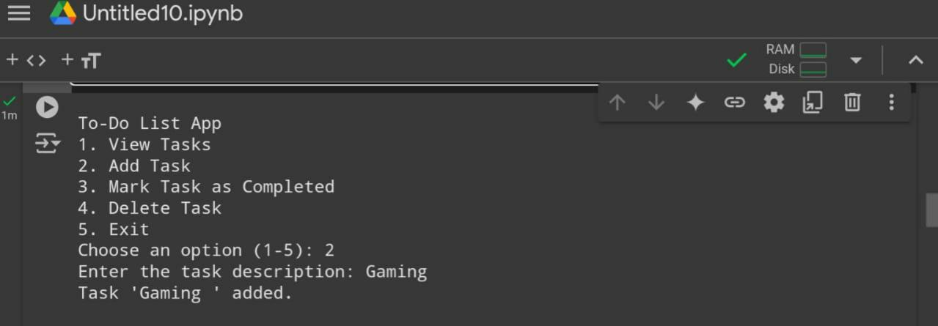
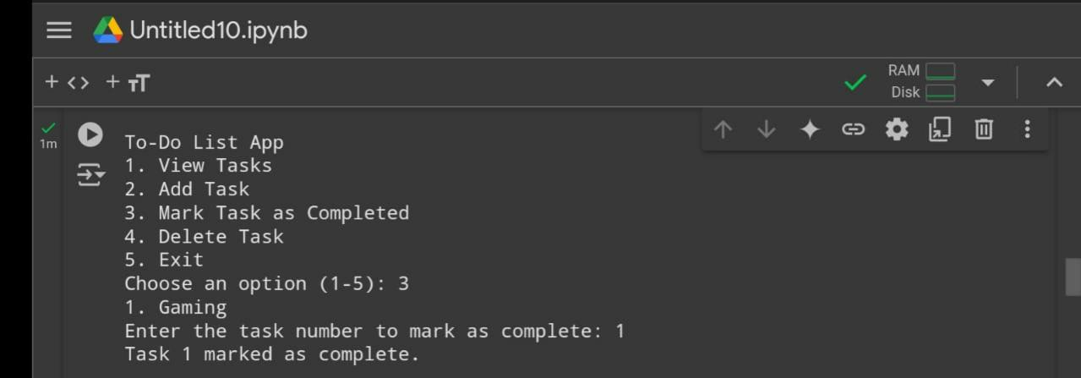
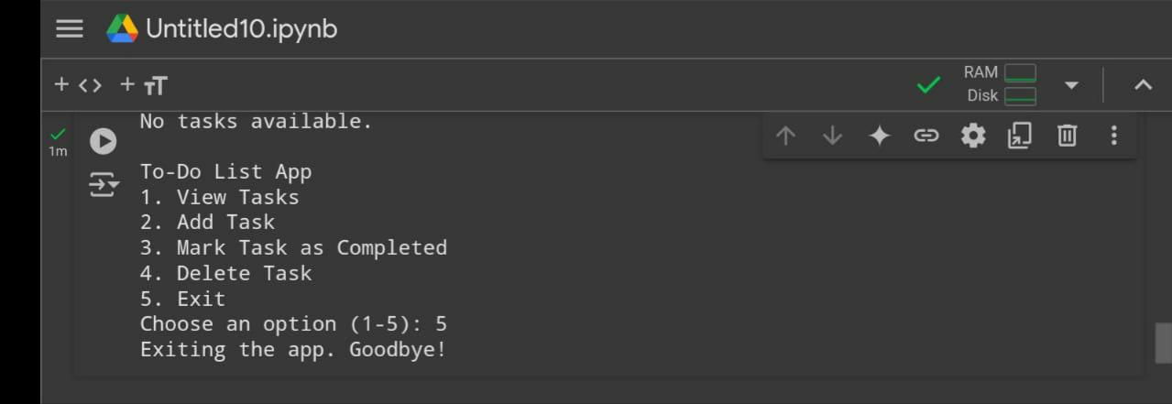
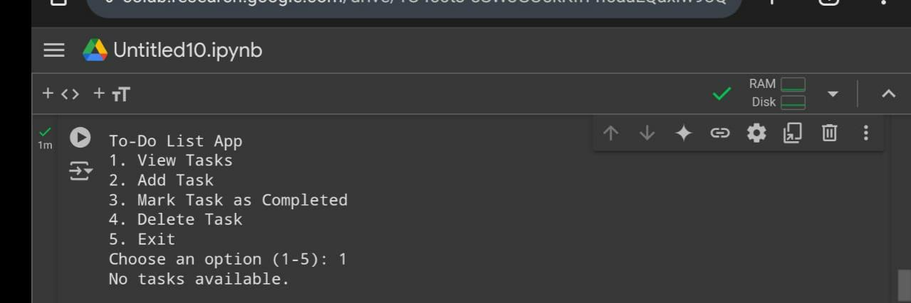
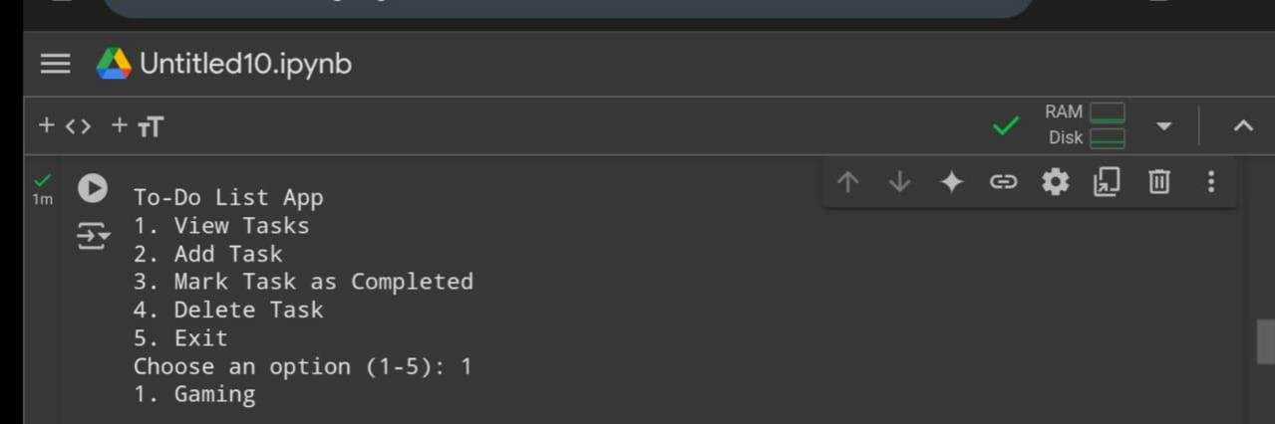
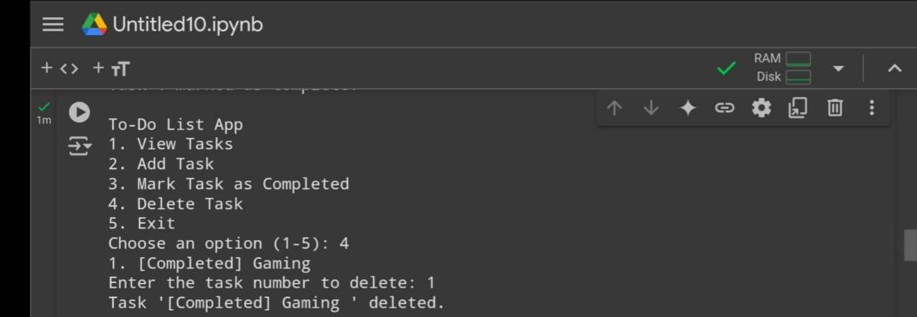
Features

- Add, edit, and delete tasks.

- Set deadlines, reminders, and recurring tasks.

- Organize by categories, priorities, or tags.

- Track progress with status updates.

- Collaborate by sharing tasks and assigning to others.

- Sync across devices and integrate with calendars.

Outcomes

- Boosts productivity and focus.

- Enhances organization and time management.

- Reduces stress and prevents missed tasks.

- Encourages collaboration and accountability.

- Provides flexibility for personal and team use.

Conclusion

A To-Do List boosts productivity, improves organization, and reduces stress, making it a valuable tool for managing tasks and achieving goals efficiently.

